ANSWERS FOR LEAGUE OF WOMEN VOTERS WATER SUMMIT

LEAGUE OF WOMEN VOTERS OF LARAMIE, WYOMING

*What is the water problem or issue your League is (or was) working to address?* The Laramie, Wyoming, League of Women Voters respects and advocates for the LWV national policy on water protection and is in support of a local water protection group called the Albany County Clean Water Advocates (ACCWA). The President of ACCWA sits on our Board and is responsible for keeping our local and state Leagues updated on water protection issues. ACCWA’s vision statement affirms that “ACCWA aspires to preserve the abundant availability of high quality water now and for generations to come.” ACCWA’s mission is to “advance its vision through education, advocacy, and the application of available scientific knowledge.” Citizens began to organize in 2008 to protest the siting of a golf course atop the Casper Aquifer recharge area.

*Identify the watershed or water body (bodies)* Southeastern Wyoming lies on the western edge of the multi-state Ogallala Aquifer. This edge runs along the mountain range lying east of Laramie and west of Cheyenne. The Casper aquifer extends from 50 miles north of Laramie to south of the Colorado border. In the vicinity of Laramie, it is present at the surface east of town and beneath other formations west of town (see Figure 3).

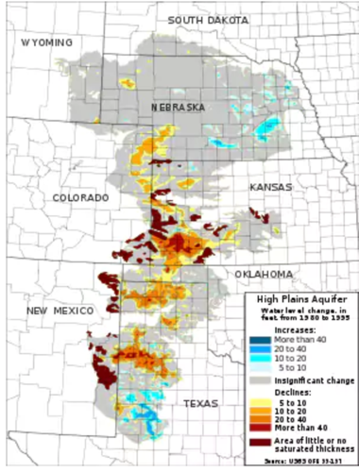  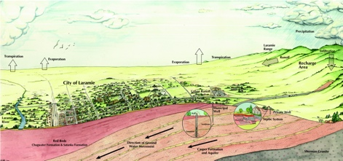

Figure 1 Ogallala Aquifer Figure 2 Casper Aquifer Figure 3 Groundwater Laramie

Interstate 80 lies about 20 miles north of the Colorado border, and crosses Albany County, the southern edge of Laramie, and the whole Casper Aquifer. Although much of I-80 corridor presents hazardous driving, more accidents occur within the four miles east of Laramie than elsewhere. The volume of traffic, the increased transportation of hazardous materials, and the driving challenge (due to a very steep decline from a mountain summit) make run-off from the end of Telephone Canyon a source of contamination to the Casper Aquifer.

The Casper Aquifer provides 60% of the drinking water for the 32,000 residents of Laramie in normal years, and up to 100% in drought years. Treated water from the Laramie River (west of Laramie, see Figure 3) provides the remaining portion of the city supply.  The aquifer is the sole source of drinking water for rural residents east of Laramie who depend on wells. Together, that’s about 86% of the entire population of Albany County.

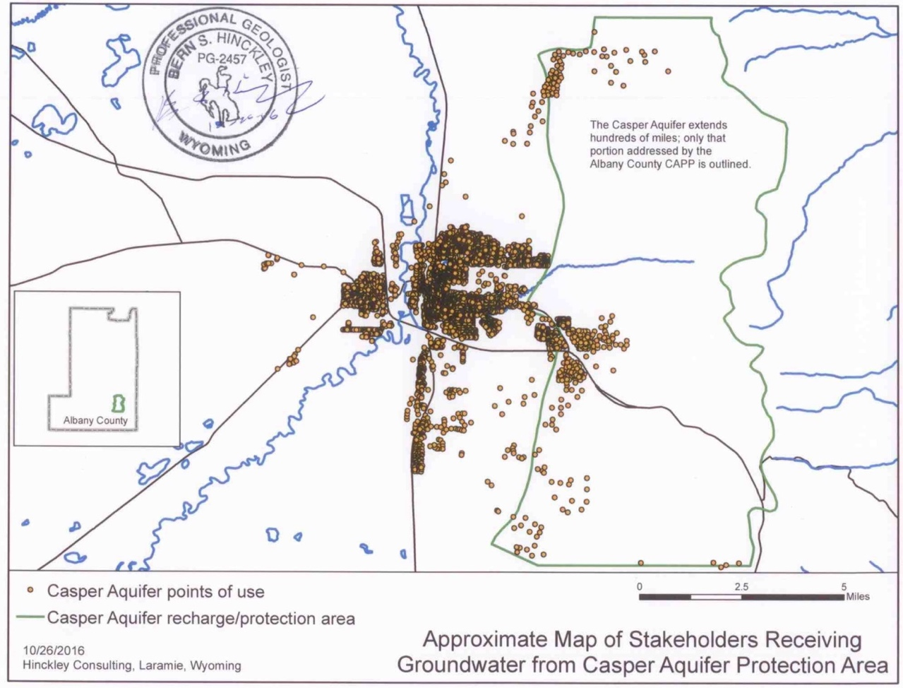

Figure 4 Stakeholders Receiving Casper Aquifer water

*What actions are being taken (or were taken) to address this?*Should the need arise, the Laramie LWV could lobby elected representatives; report on activities and explain water supply; write to the newspaper; support the master plan, zoning and open spaces; hold unit meetings; circulate a pro/con flyer; ask members to take action; and/or cooperate with Sierra Club or Citizen’s Climate Lobby. At the moment, the Laramie League is following ACCWA and its advocacy work through its president who works on the Natural Resources portfolio.

*What is the result of your work, and what remains to be done?* Our local water protection group ACCWA has been successful in influencing the local governmental bodies, e.g., the City Council/Planning and Zoning Commissions and County Commission to stand firm on existing regulations. Requests have been made to the City Council to loosen ordinances so that a business located over the Aquifer could use/store hazardous wastes. One recent example is a car dealership that promised to protect the Aquifer by storing their chemicals in “modern engineered storage tanks” that would “never leak.” Due to the education and advocacy work of ACCWA and the outpouring of community opposition, the Laramie City Planning and Zoning Commission turned down the exception request. It also refused to make changes its planning staff proposed to relax the ordinance.

Voters will soon decide on an Albany County-wide specific purpose excise tax that includes an ACCWA request of $250,000 to construct additional monitoring wells. The Laramie League will research and distribute pro-con fliers on the Specific Purpose Tax in July-August 2018.

*Did you work with other organizations? Are there ongoing partnerships that were built*

*or have been maintained?* The most important partnership, though it is informal, is with Albany County Clean Water Advocates. ACCWA in turn is supported by environmental lobby groups and local interest groups. Laramie League members serve as observers attending the Laramie City Council meetings. The observers make regular reports to the board, providing a broader lens on community issues impacting water.