Every five years or so since the Dust Bowl of the 1930s, our federal government has debated, passed, and signed a complex bill that drives food and farm policy. From farmer’s markets to farm fields, nutrition to nutrient management plans, and everything in between, each Farm Bill covers a lot of ground. Our current 2018 Farm Bill has guided agricultural policy for the last five years and spent nearly $430 billion dollars on our food and farm system (1). Now, it’s time for Congress to write Farm Bill 2023. Let’s make sure they know – like we do – how this Farm Bill can support our Mississippi River.
While the Farm Bill is a massive piece of legislation, there is one slice that can make a big impact on our waterways -- the Farm Bill’s Working Lands Conservation Programs. These programs fall under the Conservation Title of the Farm Bill and account for almost $30 Billion (or 7%) of Farm Bill spending. These voluntary programs help farmers reduce soil loss and mitigate environmental impacts through practices that support healthy soil, flood resilience, and functioning habitats. Farm Bill conservation programs offer some of the most cost-effective solutions available to agricultural and ranching communities. What’s more, farmers up and down the Mississippi River strongly support and benefit from these programs, and there is always far more interest than funding.
The Conservation Title experienced major cuts in the 2014 Farm Bill and has been subject to repeated annual cuts through sequestration and the appropriations process since then. We urge Congress to protect and increase funding for Conservation Title programs like the Environmental Quality Incentives Program (EQIP) and the Conservation Stewardship Program (CSP) in the 2023 Farm Bill and ensure IRA funding is used for climate-smart agricultural practices and Farm Bill conservation programs. This funding is critical to begin to meet the demand from farmers and ranchers in the ten Mississippi River states for these clean water and healthy habitat practices.
Photo credit: Land Stewardship Project
How Farm Bill Conservation Programs Help Water Quality
Programs and funding in the Farm Bill help reduce pollution by ensuring that farmers and ranchers have access to a variety of tools that help support not only healthier farms but also healthier rivers. For example, conservation programs can fund cover crop systems that keep roots in the ground, leading to soil with increased organic matter and increased capacity to store flood water. Conservation programs can fund riparian buffer strips or perennial prairie strips that provide habitat for native plants and animals.
Farmers rely on the Farm Bill’s Conservation programs to help them make their farms more resilient and productive. But these programs can only help farmers if they are funded. The 2018 Farm Bill included almost $30 billion in funding for the Conservation Title, and the Inflation Reduction Act of 2022 (IRA) presents an opportunity for an additional $20 billion in funding for these programs over the next 5 years. We urge Congress to protect funding for conservation in the Farm Bill and in IRA.
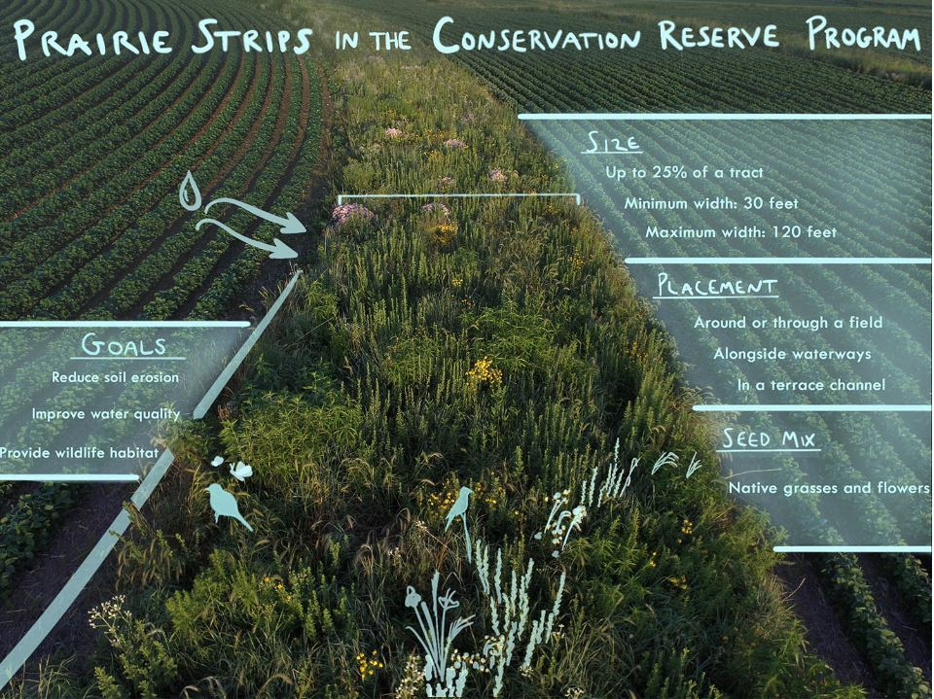
Farm Bill Conservation Programs provide vital environmental protection and employment opportunities in rural America. For example, the pictured prairie strip in an Iowan farm field is supported by a Farm Bill Conservation Program called Continuous Conservation Reserve Program (CCRP). The CCRP pays farmers to install partial field conservation practices to reduce soil erosion and preserve critical wildlife habitats, like wetland buffers, filter strips, riparian buffers, wildlife habitat buffers, wetland restoration, windbreaks, and pollinator habitats.

Photo/Graphic credit Omar de Kok-Mercado and Iowa State University STRIPS Program.

