**Background**

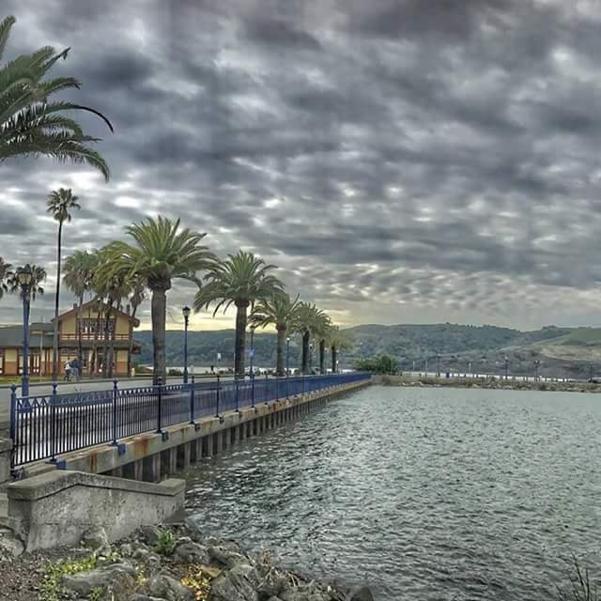Benicia, California is located on the Carquinez Straight, part of the San Francisco Bay-Delta Estuary, which includes over 1000 miles of waterways, ecologically sensitive wet lands, and drains the main sources of water for over 26 million people and millions of acres of irrigated farm land. The Bay-Delta is surrounded by 12 different counties most of whom rely on the tributaries of the Delta for their water. Other areas in Central and Southern California rely on it too. The State Water Project and the Federal Central Valley Project carry water through and beyond the Delta more than 700 miles, helping to make California’s economy the fifth largest in the world.

**General Concerns**

Water concerns for all Californians revolve around the need for a consistent, reliable source of clean, water. There are multiple sources of water in our drought-ridden state. We rely on rainwater which varies from 2 inches or less a year in the south to 20 inches annually in the northern mountains. Most rain occurs in the winter and spring months, leaving residents to rely on melting snowpack, water storage facilities, and ground water during the hottest times of the year. During the recent 5-year drought most communities had some kind of water conservation programs in place, mandatory or voluntary water rationing. For example, Benicia residents were asked to reduce our water usage by 25%. Lawns were replaced with drought resistant plants, buckets appeared in showers to collect used water, citizens formed a water patrol reminding residents and businesses not to water in the heat of the day. We were successful, reaching a 33% reduction, but in August of the last drought year we didn’t receive our full allotment from our main water source, and had to buy water from the Mohave Desert Water District; $900,000 for 3 months worth of water for 28,000 people.

**Current local and regional issues**

Not only is the quantity of water available an issue, but the quality of the water is a problem too. Our city and others around us are having a harder time providing enough safe, clean water to our residents. Our primary source of water in Benicia is the Delta, from a slough that is affected by salt water tides. When less fresh water flows through the Delta because of drought, increased

upstream use or storage our source becomes too salty to use. At certain times of the year we must abandon that source and pay for another. Water treatment and sewage treatment facilities have been upgraded which have caused our current water bills to almost double. Many of our residents are on a fixed income and can’t afford these large increases.

Several years ago Governor Brown and the State Department of Water Resources proposed building twin tunnels 40 feet in diameter and 35 miles long to carry water directly from the large upstream Sacramento River around the Delta to pumping stations and into aqueducts that carry water to the San Joaquin Valley and Los Angeles Basin. The current ideation, the California Water Fix, hopes to increase available water to the southland. It would reduce fresh water flows through the Delta, allow more salt intrusion, which in turn would return reduce drinkable water available to towns and cities in the Delta, cause thousands of acres of farmland to go fallow because of salt intrusion, and affect recreational and commercial fishing from the Delta, through the Bay, and along California’s Pacific coastline. Some Bay Area cities, like Benicia, would benefit from new outtakes upstream of the salt line, but it will come with an increased cost to rate payers. The proposed Water Fix project is projected to cost $14 billion dollars. While there was no financial sourcing written into the original plan, several schemes have been suggested, but none have come to fruition. Currently funding is being sought from water districts and water agencies who will pass building and operation costs through to their water users via fee hikes. Water will cost all users more. Still there is no way to guarantee that the amount of water promised will be delivered through the tunnels because of threat of drought at the water source area.



**League Involvement**

The LWV California “supports measures that promote the management and development of water resources in ways that are beneficial to the environment with emphasis on conservation and high standards of water quality.” Our State League has lobbied for dozens of state water bills since 2014 which involve water conservation, water availability, and quality. In our June primary election, the State League supported and helped pass a bond issue that included moneys for water conservation, water for disadvantaged communities and flood control. A primary concern for the League is that commissions made of political appointees have control over water storage projects and water allotments from them. The LWVC opposes the California Water Fix and successfully lobbied to have proposed funding for the twin tunnels removed from the final draft of an $11 billion water bond in the 2014 election.

Since 2014, members of the LWV Benicia have been researching information, attending hearings, and offering public information sessions on the Bay-Delta/ Water Fix plan. Over the last four years, we have hosted 6 different panel discussions and a voter’s forum with public and elected officials who have extensive knowledge of the California Water situation in general and the Water Fix in particular. The meetings have been well attended both by members and the general public and allowed attendees to learn basic facts about water sources as well as the pros and cons of the Water Fix. One event included a field trip to a large park in the Delta where a ranger explained the intricacies of the ecology there. At our 2018 Annual Program Planning meeting we agreed to continue with informing the public about water issues in California. Our annual water forum this year was titled “Water Rising” and included discussions about local effects of climate change and sea level rise, the decline in water allocations to our city, and an explanation of the rising cost of water by our mayor. The room was packed with attendees, many of them with their water bills in hand.

**Partner Organizations**

We partnered with the City of Benicia, Benicia Public Library, and the American Association of University Women (AAUW) to sponsor venues for our informational meetings. For speakers and information we turned to Restore the Delta, the State Department of Water Resources, University of California Davis, Solano Land Trust, Solano Irrigation District, LWV Bay Area, Delta Planning Commission, Suisun Marsh Conservation District, NASA, National Estuarine Research Center, and the Friends of the San Francisco Bay Delta Estuary.

**Actions and Impacts**

Our local League has educated hundreds of residents about the source, the cost, and the quality of our water. Attendees to our sessions have become motivated to learn more, to seek out more information about water allocations, conservation, sustaining our environment, and to be more politically active on these issues.

**What needs doing, next steps**

The logical next step would be for the LWV Benicia to do a study on the regional effects of the California Water Fix, so we could then take action. This will be difficult to do, not only because of limited Human Resources of our small chapter, but also because the Water Fix appears to be a dynamic, ever changing plan that is hard to pin down. We will continue to inform our members and public about changes in it and other water issues as they arise. We will be examining a November 2018 ballot measure, the Water Supply and Water Quality Act of 2018 in a public forum this fall.

**For More information on California Water:**

LWVC.org

Bayareamonitor.org

Mavensnotebook.com

[www.californiawaterfix](http://www.californiawaterfix)

[www.restorethedelta.org](http://www.restorethedelta.org)

Channel.nationalgeographic.com/water-and-power-a-California-heist