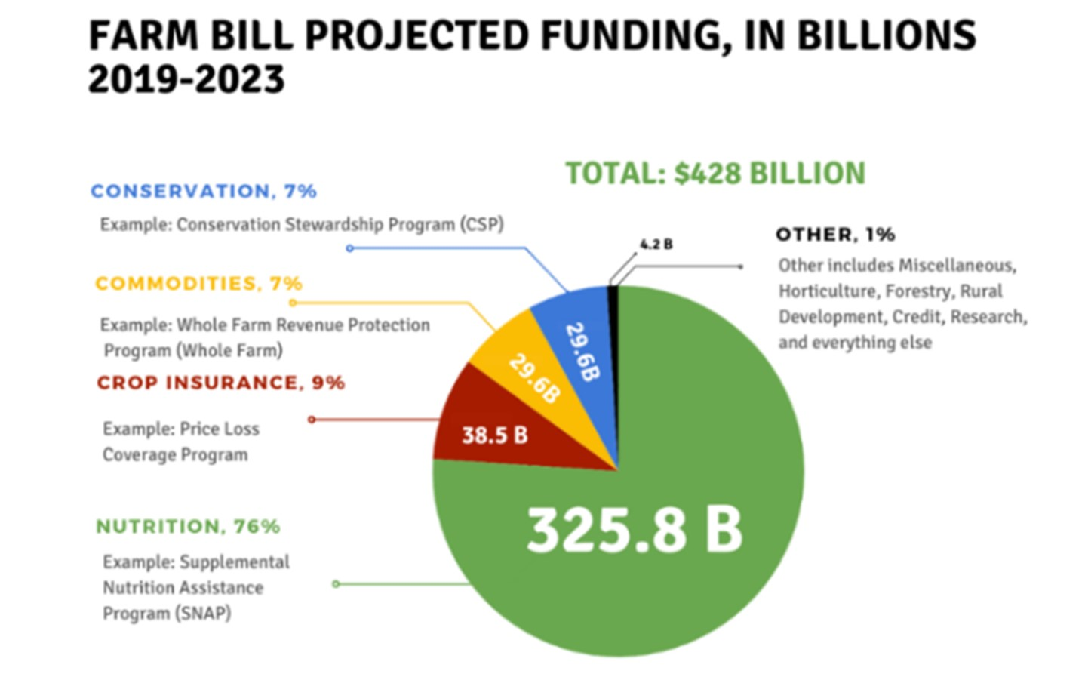
The Farm Bill’s Working Lands Conservation Programs account for 7% - almost $30 Billion - of Farm Bill spending. These voluntary programs help farmers reduce soil loss and mitigate environmental impacts through practices that support healthy soil, flood resilience, and functioning habitats.
Source: USDA Economic Research Service Based on Congressional Budget Office, Direct Spending Effects for the Agriculture Improvement Act of 2018 (2018 Farm Bill), December 11, 2018 (via National Sustainable Agriculture Coalition).

