Restoring Lake Michigan: Her Past, Present and Future, League of Women Voters Lake Michigan Region
Conference October 21, 22, 2022

Catherine attended this conference in Sheboygan, Wisconsin. The Lake Michigan Region League includes member leagues from Michigan, Indiana, Illinois, and Wisconsin.

Friday afternoon field trips were at the Wisconsin Maritime Museum, canoeing on Sheboygan River and Hike the Glacial Lakes Conservancy Willow Creek Trail. I hiked the Willow Creek Trail which was led by two naturalists and the Executive Director Jennifer Born Rutten. Glacial Lakes Conservancy offers land conservation options, organizational support, and technical guidance to landowners and organizations in Sheboygan, Manitowoc, and Fond du Lac counties in Wisconsin and Kewaunee and Calumet counties in Michigan. The location of our hike was right in the heart of Sheboygan and has some very specific restoration needs as they relate to street run off mitigation and invasive plants and native plant reintroduction. The teamwork and community engagement are vital. Support from the local government agencies, department of Natural Resources, water department and citizens combine to build the work teams and plans to restore this vital watershed area.

Funding for the purchase of this property was secured from the Sheboygan River Natural Resources Damage Assessment (NRDA) settlement. These funds were established with the purpose of restoring natural resources that have been previously degraded by the discharge of hazardous substances into areas such as the Sheboygan River.

Our evening program was a conversation with United States Senator Tammy Baldwin of Wisconsin. As a leader in the Senate championing stronger Buy American policies, Senator Baldwin worked to include Buy American reforms in the Infrastructure and Jobs Act, which makes historic investments to create jobs and build America’s infrastructure. The bipartisan legislation invests in fixing roads and bridges and rebuilding water infrastructure, including help for local communities to replace lead service lines and address per-and polyfluoroalkyl substances (PFAS) chemicals in order to provide safe and clean drinking water across the state.

Saturday’s opening program was: “The Sheboygan River Cleanup: Revitalization of a Community and Initiation of a new Era of Great Lakes Restoration by Heather Williams, Program Manager with the US EPA’s Great Lakes National Program Office. The Sheboygan River was one of the most contaminated waterways on the Great Lakes. While regulatory plans for a cleanup were moving forward, substantial contamination was to remain, leaving the community with a river they could not fully use or enjoy. Thanks to Great Lakes Restoration Initiative funding in 2010, the Sheboygan River was finally cleaned up. The project became a model for how to get things done in other Areas of Concern. Heather was the Sheboygan River Project Manager from US EPA and discussed the project and other restoration work around the Great Lakes. She described the importance of collaboration across contractors and the need to review progress, readjust if necessary and build best practices for future projects. Here is the list of Great Lakes Areas of Concern: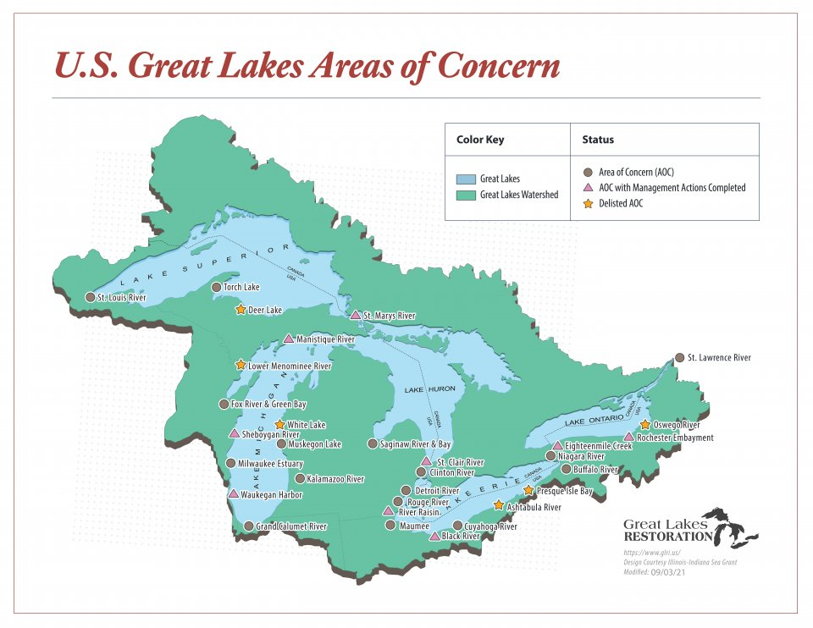

On Saturday afternoon, Russ Green, the superintendents of NOAA’s Wisconsin Shipwreak Coast National Marine Sanctuary presented “History Beneath the Waves: The Wisconsin Shipwreck Coast National Marine Sanctuary. Designated in 2021, the 962 square-mile Wisconsin Shipwreck Coast National Marine Sanctuary provides stewardship for our nation’s maritime heritage in Lake Michigan, including 36 well-preserved historic shipwrecks. Through broad-based research and education programs, the sanctuary advances Lake Michigan conservation and inspires future generations to protect our Great Lakes and oceans. Russ provided an overview of the sanctuary, highlighting recent research and outreach efforts.

