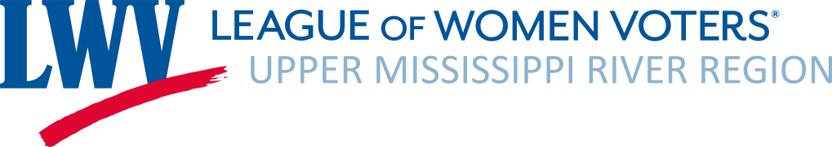

Treasurer’s Report
July, August, 2023

- Operating: June, July 2023 Activity
  - Revenues:
Renewals $450.00
1 Donation $195.53 Michael Anderson 1 Mississippi
Interest Income $2.66
In Kind Contributions $795.83
Total Revenue $1,444.02
  - Expenses:
$551.04 Board Retreat Sunday Dinner
$108.39 Exhibit Materials
$175.22 Supplies & Copying Renewal Letters
$3.96 PayPal Fees
$795.83 Donated Travel Supplies
Total Expenses: $1,634.44
Net Operating Revenue $190.42

- Bank balance as of July 31, 2023: $12, 029.86 (includes ERC Grant and Judy Beck Memorial Fund)
  - Judy Beck Memorial Fund balance (generally for advocacy activities): $100.00*
  - ERC Restricted Grant II balance: $166.82
- Current 2023-24 memberships: 19 as of August 4, 2023 – New Member New Ulm, Minnesota
- Included with Treasurer’s Report:
  - Budget Vs. Actuals YTD July 2022 – July 2023
- New Budget 2023-24 loaded into QuickBooks.
- Bank Signatory now includes Tamara Prenosil and Gretchen Sabel
- Google Drive– Tamara Prenosil has loaded Secretary files to our Google Drive
Balance Sheet as of 7/31/2023
ASSETS
Checking Account | $6,692.32
Savings Account | $5,334.88
TOTAL ASSETS | $12,029.86
LIABILITIES | $0.00
EQUITY
ERC Restricted Grant II | $166.82
Judy Beck Memorial Fund | $100.00
Undesignated | $11,953.46
TOTAL LIABILITIES & EQUITY | $12,527.82

