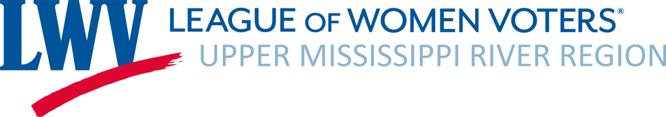

Treasurer’s Report
October 3, 2022, Board Meeting

- Operating: August/September 2022 Activity
  - Revenues: $1,990.00
$775.00 Memberships
$1,215.00 Donations
  - Expenses: $1,567.78
$1,460.00 US Convention/Conference
$106.00 PO Box 6 Month Renewal
$1.78 PayPal Fees
- Bank balance as of September 30, 2022: $11,706.93 (includes ERC Grant and Judy Beck Memorial Fund)
  - Judy Beck Memorial Fund balance (generally for advocacy activities): $300.00
  - ERC Restricted Grant II balance: $166.82
- Banking: Investigated Ally Online Bank for savings but they do not offer savings to non-profits. With Board approval at our August meeting, deposited $5,000.00 into a DuPaco savings account, interest .15% original 07% apy
- Current 2022-23 memberships: 33 as of September 30, 2022
- St. Louis Metro is now a member, does this require by-laws change?
- Included with Treasurer’s Report:
  - Final Budget Vs. Actuals 2021—22 FY22 P&L
  - Budget Vs. Actuals YTD July – September, 2022
- Link for Membership Roster as of 9/30/2022 Sent to Board Under Separate Email
  - Steve & Mary Ploeser ask for volunteers to call leagues to remind them to renew.

Balance Sheet as of 9/30/2022
ASSETS
Checking Account | $6,376.93
Savings Account | $5,330.00
TOTAL ASSETS | $11,706.93
LIABILITIES | $0.00
EQUITY
ERC Restricted Grant II | $166.82
Judy Beck Memorial Fund | $300.00
Undesignated | $11,240.11
TOTAL LIABILITIES & EQUITY | $11,706.93

